Clear statement of work done:

Statement of XP roles/other responsibilities and contributions

from week 7 to 13, my XP role is primarily manager, though I also got involved in the role of programmer and tester. Therefore, besides overseeing team's progress on the project and guiding the team, I also took part in the actual app development and testing.

Weekly plan and reflection

Week 7

* Plan to do: finish documentation, client communication
* Actually did: everything planned
* Actually achieved: everything planned

Week 8

* Plan to do: client communication, set up speech to text
* Actually did: client communication
* Actually achieved: everything actually did

Week 9

* Plan to do: client communication, set up speech to text
* Actually did: client communication
* Actually achieved: everything actually did (speech to text was set up by Harry)

Week 10

* Plan to do: client communication, json validator, status report
* Actually did: everything planned
* Actually achieved: everything planned

Week 11

* Plan to do: client communication with meeting minutes, prepare for the presentation
* Actually did: everything planned
* Actually achieved: everything planned

Week 12

* Plan to do: client communication with meeting minutes, navigation drawer UI
* Actually did: everything planned
* Actually achieved: everything planned

Week 13

Plan to do: final deployment, final presentation

Actually did: everything planned

Actually achieved: client was satisfied with our final product

**Reflection:**

The work through week 7-13 is challenging but fun. During week 1-6, we spend much of our time on the design and research stage: trying to understand client requirements, convert that into user stories, and figure out the way to implement these stories by creating a usable product. Therefore, most of the coding work has been left to weeks 7-13, However, we performed outstandingly as we swiftly finished a product that has quality beyond our own expectation. This can’t be finished without extensive planning, documentation and research done in earlier weeks, but the major contribution is still made by hard working team.

XP has been an important part throughout our development. By sticking to that methodology, we were able to arrange the team in a much better efficiency into development. While each people has a distinct XP role assigned to them and they perform their dedicated job, the most important aspect of XP methodology, client communication, was carried out extremely well by the team. Meeting with client was hold each week, to ensure the team and client always be able to keep tracking about other’s requirement/progress. Minutes was recorded after each meeting and was used as a guide for the team to plan next week’s job.

Time has been a major limitation factor in the project, as the team has to deal with assignments from other courses. Although the final product was a great success, there’s always more room for improvement if we had more time.

After all, the project was a great success, and I learned a lot from it.

**Evidence:**

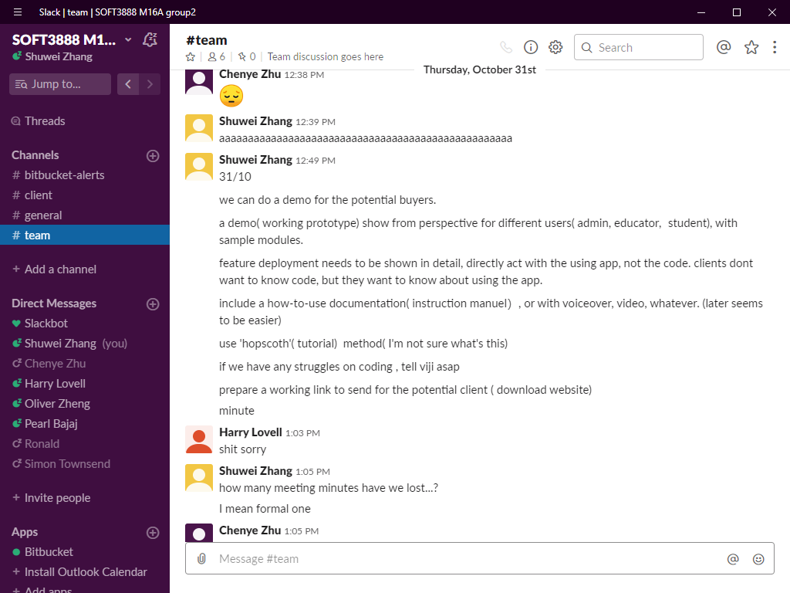

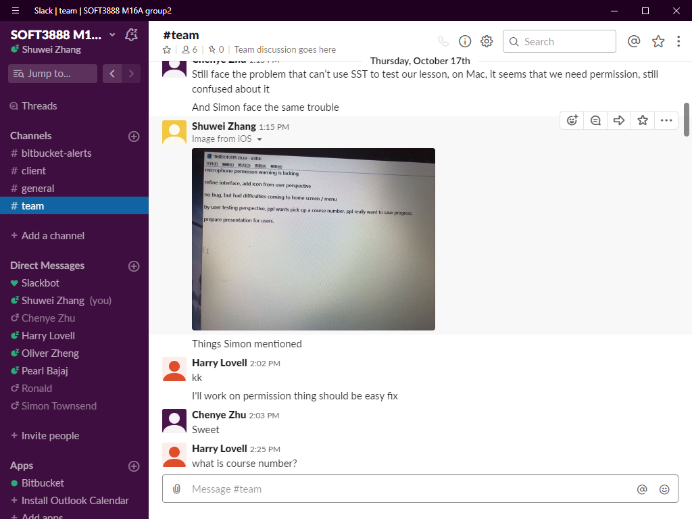

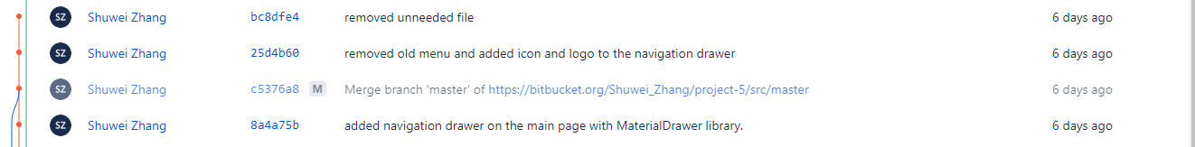

<https://bitbucket.org/Shuwei_Zhang/project-5/wiki/Documentation#markdown-header-status-report-7>

<https://bitbucket.org/Shuwei_Zhang/project-5/wiki/commits/5784a0f49881d6c2e845e7622874ccb40ac10c9a>

Extent of that work:

**All technical work**

*json validator

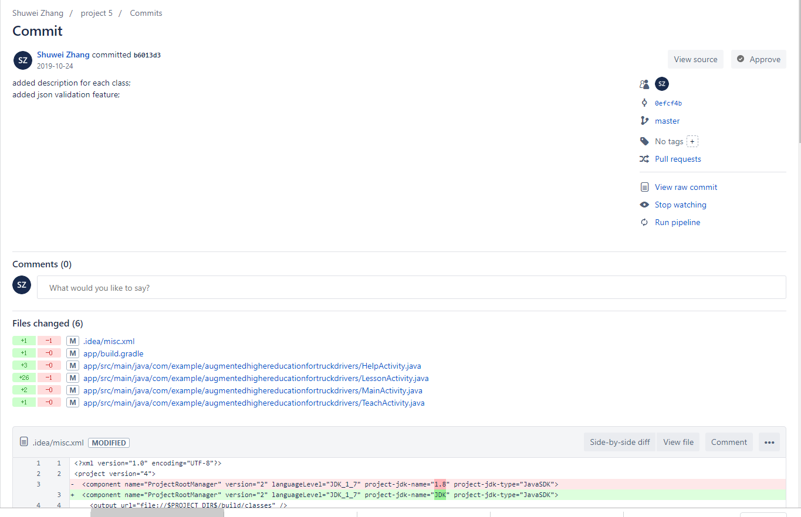

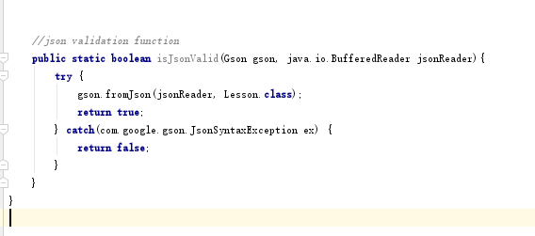

*navigation drawer

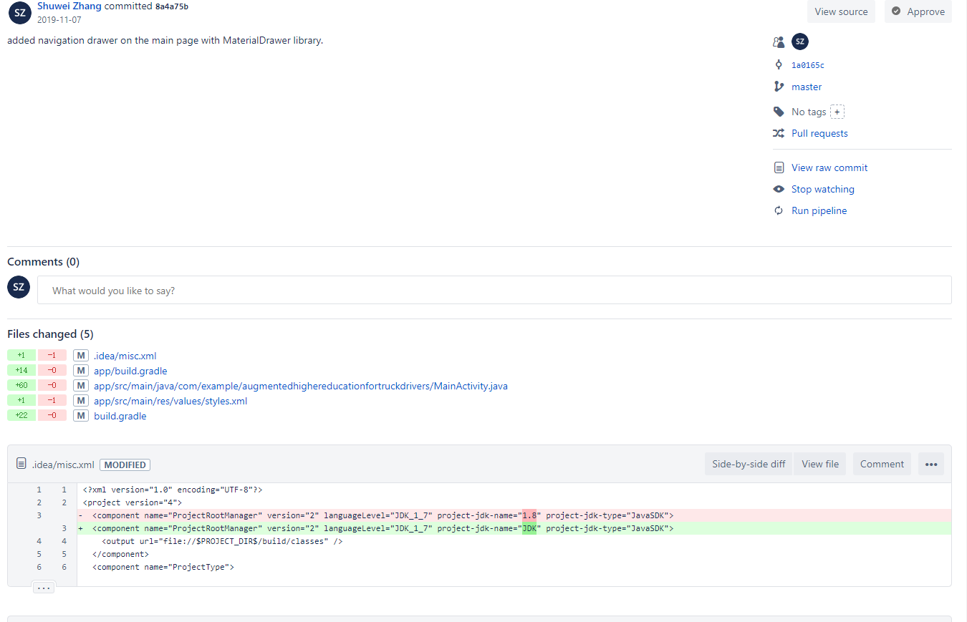

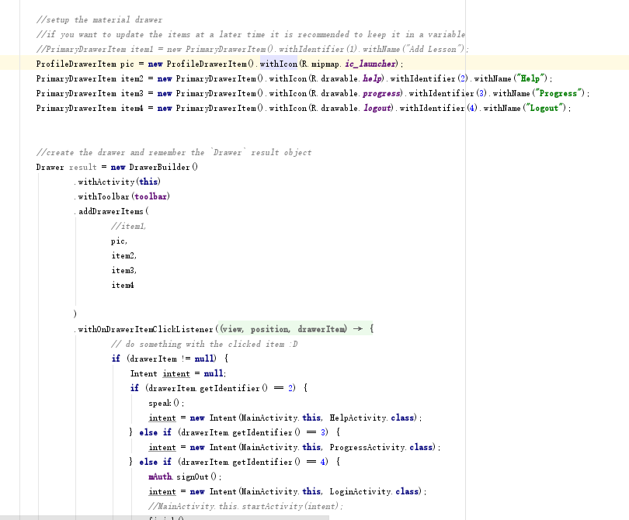

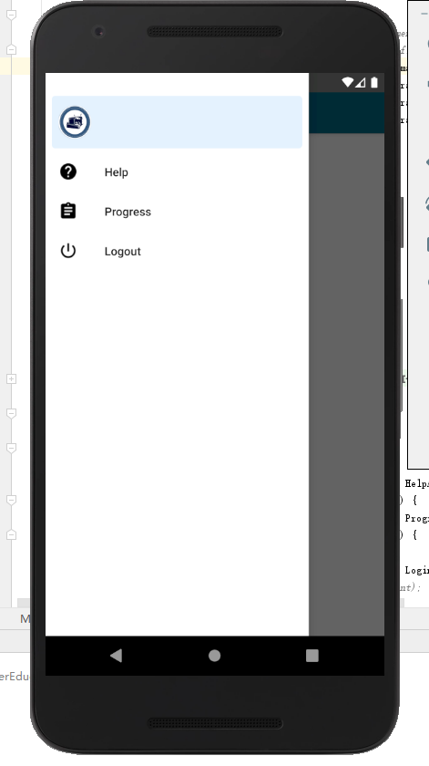

**Reflections**

The technical work for me is a process of learning, researching, and trail-and-error process on programming. As I have no former knowledge on Android programming, everything was learnt from scratch. By learning from various online sources such as Youtube videos, and google official documentations, tutorial websites, I’ve been able to produce a decent result of code module.

The most challenging part of technical work is, maintaining the code integrity. Since I was dealing with code that was not written by myself, extra caution must be taken to prevent unwanted broke down of other code parts after implementing new features. The XP methodology helps me to do that – the communication within team allows me to analysis the problem and produce a solution extra quickly. Regression testing was also performed by me to make sure the former code doesn't break down. My implementation of the navigation drawer is a perfect example of this idea – While one of my teammate’s implementation requires an unnecessary refactor of existing code or will otherwise fail, mine implementation successfully avoided it, therefore saving workload for the team, and maintained integrity of the code.

In the future, I will keep on learning and focus on teamworking, especially cooperate development as a software developer.

**non-technical work**

The non-technical work done by me to ensure quality of work is mainly by Analysis, documentation and communication, By taking active part in team discussion, I was able to help the team organize the ideas to produce a systematic approach on how to finish current work. By writing status reports, I was able to help the team to track progress and plan for upcoming weeks, therefore helping team on time management. And by communicating with clients and writing munites, I was able to bring the team latest message from the client, therefore helping to adjust the work for the team based on client requirement.

Evidence:

<https://bitbucket.org/Shuwei_Zhang/project-5/wiki/commits/5784a0f49881d6c2e845e7622874ccb40ac10c9a>

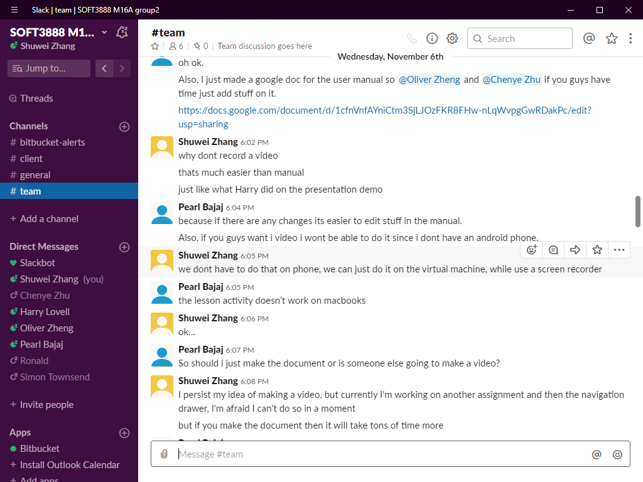

Other contribution to group processes:

The major contribution of mine to the group process is communication with the client. Since not every team member can participate in the meeting due to time limitation, Jack and me had decided to attend the meeting everytime, while Jack showing client current team status, I was able to keep track of the meeting minutes.

Also, discussing the technical/non-technical aspect of our project with other team member has also been contributed to the project, such as coding method and documentation. By providing ideas and tutorials, I was able to help other team members to get on track if he/she encountered difficulties.

I also Took part in the issue tracking. By raising issues after finding a task to do, assigning issues to different people, and tracking issue's progress until they're resolved/closed, I was able to help the team via providing latest information and guidance on the upcoming work.

**Group activities**

Evidence:

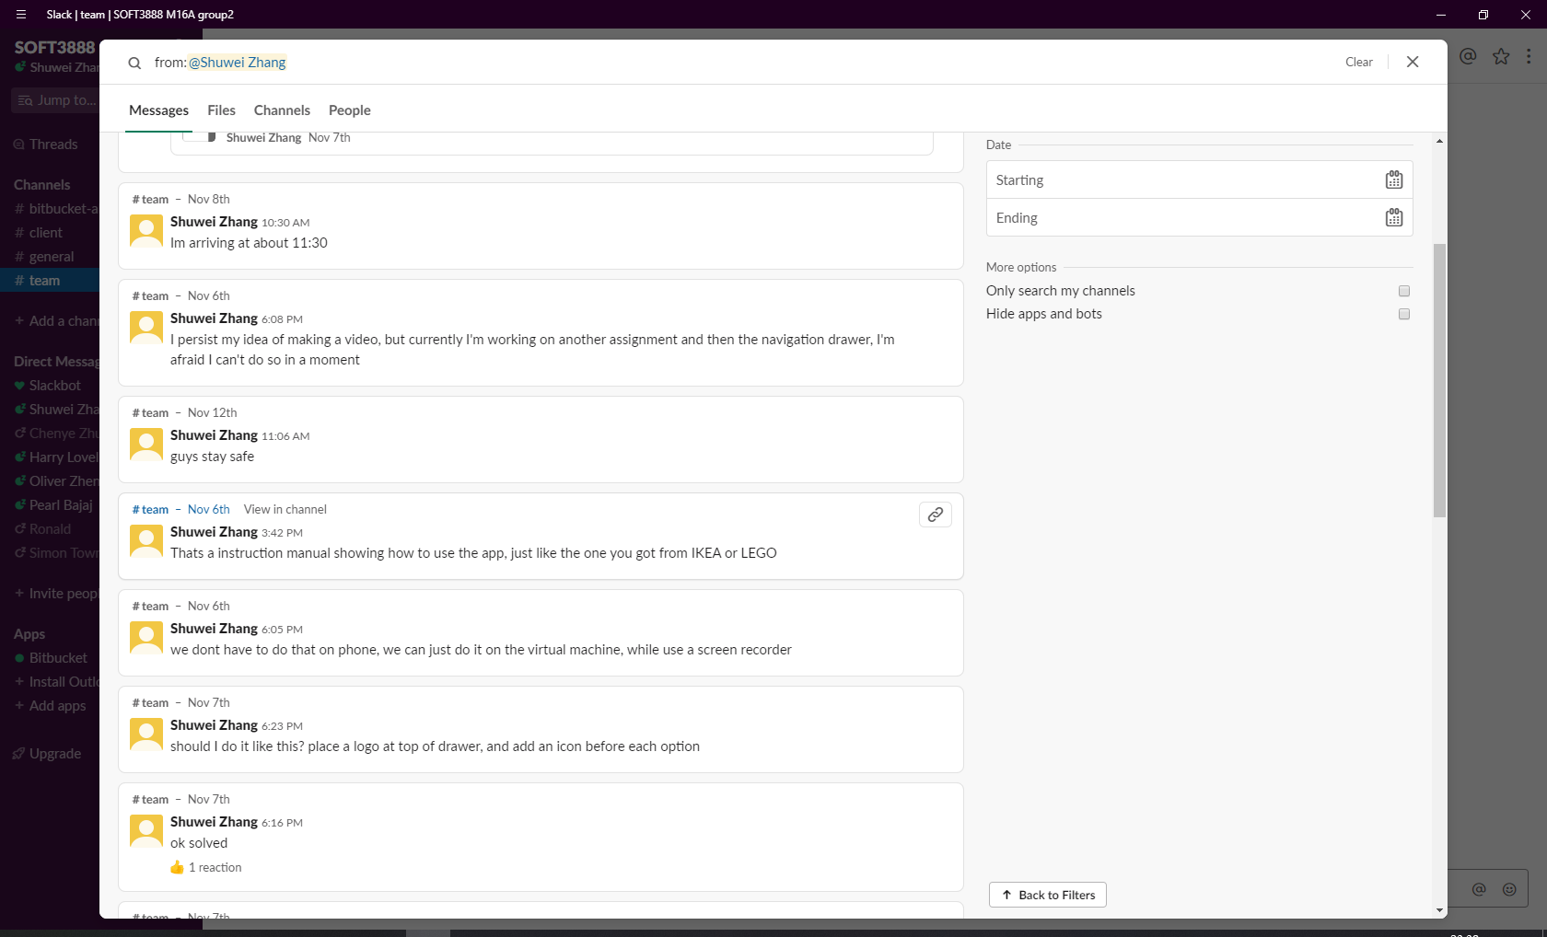

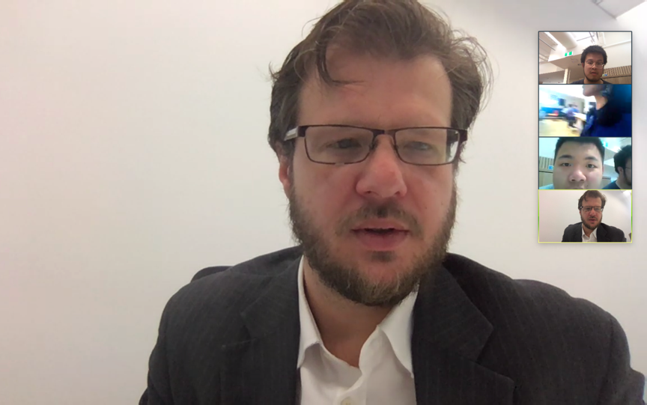

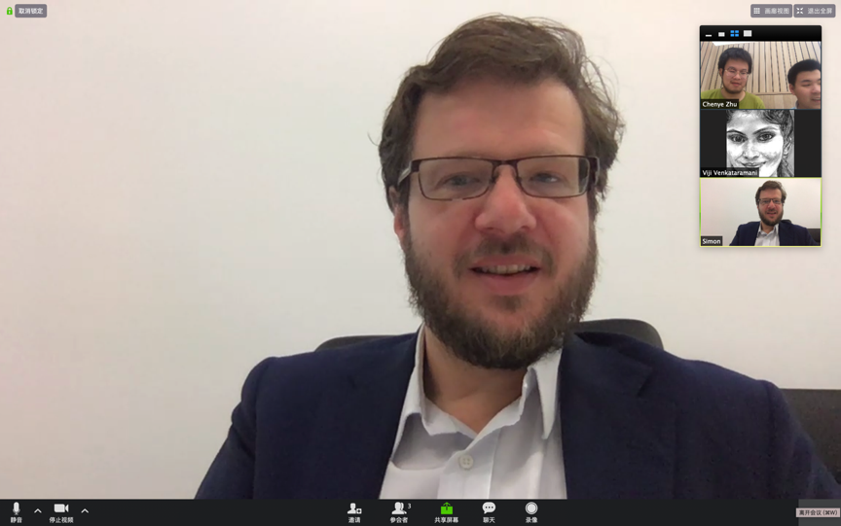

**Collaboration and teamwork**

Evidence:

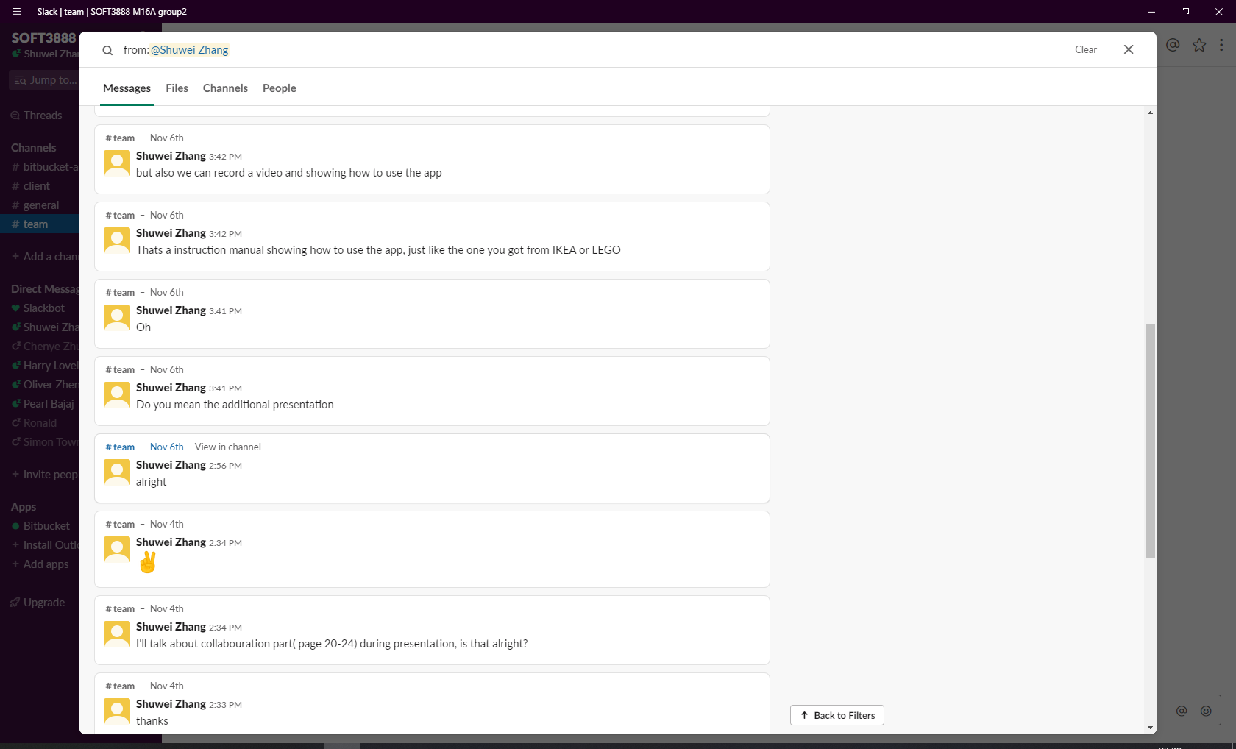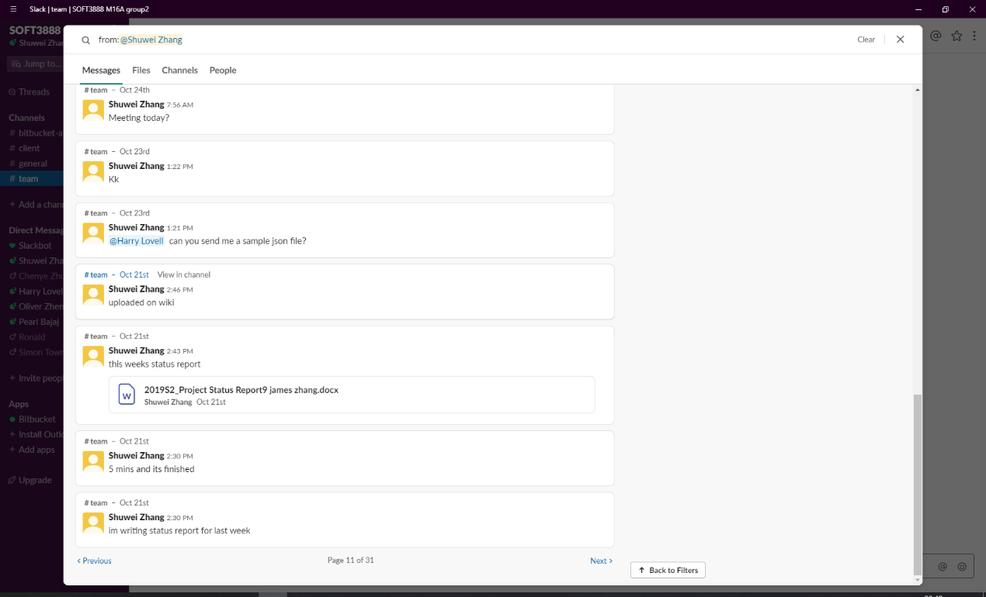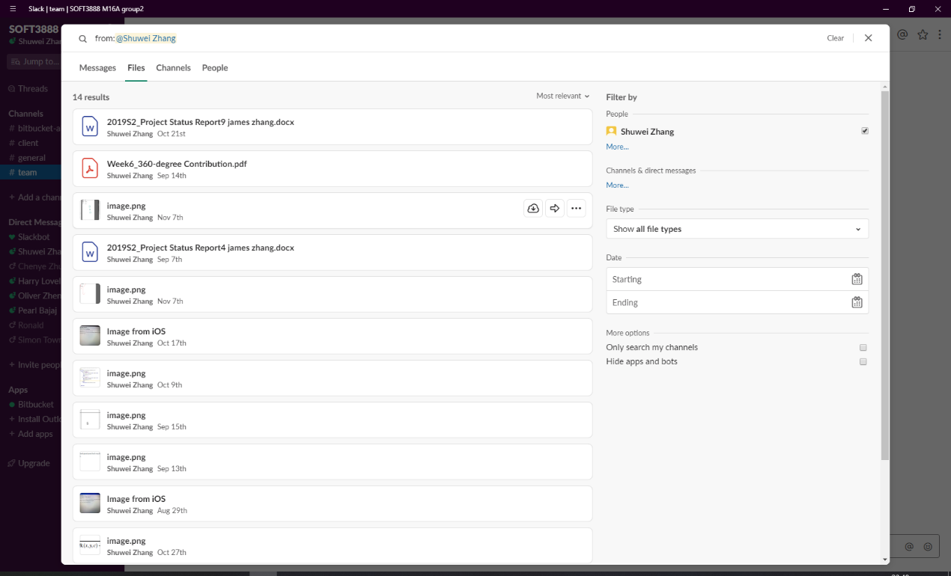

**Issues**

Evidence:

